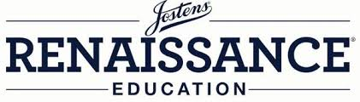

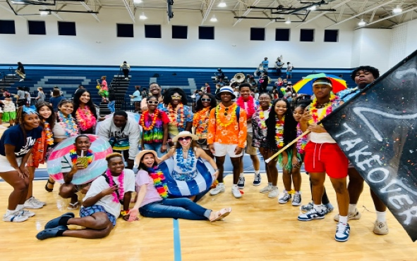

Titan Renaissance Leadership Program (TRL) 2023-2024
5B/5th block
Ms. Alia Elkhatib
aelkhatib@madison-schools.com

2023-2024 Team Members:

- Srila Anugu
- Johari Bacon
- Austin Brown
- Laci Buchanan
- Schyler Fogg
- Taniyah Ford
- Tariyiona Glover
- Shanti Guice
- Akayla Hughes
- Odyssey Mahoungou
- Dynala Sims
- Jakalyn Smith
- Malique Smith
- McKenzie Travis
- Shelby Whitley

Welcome! I am so excited to be over the Titan Renaissance Leadership (TRL) program again this school year. I am so proud of all the wonderful successes we had last school year. I look forward to continuing this program while implementing new and creative opportunities for our students. This year we have fifteen awesome members on our team.

The purpose of this class is to promote a positive and inclusive culture at Ridgeland High School. I know that this school year will once again be different because of the ongoing pandemic, but I know that with our awesome members, we will think of ways to incorporate fun and excitement into our school’s daily routine. I am all ears for different ideas!

As far as grades are concerned, I will give you each a daily participation grade. This grade will be determined upon attendance, helpfulness, and attitude. Diminished participation grades will carry throughout the course of the term. Please remember to be present and on time for class each day. There will be days that are more flexible than others, but your attendance and presence are necessary for success.

Several of our responsibilities include but are not limited to the following: Creating and distributing Renaissance Cards, promoting school spirit on social media, dressing up on spirit days, helping with pep rallies, planning the Renaissance Rally and Decision Day, and assisting with various school functions.

Traditionally, I like to have group t-shirts for TRL events and our yearbook photo. This would require a TRL fee of $25.00. Let’s discuss and see how we feel about this, as I was not able to make it happen last year due to the split group.

Remind is set up to remind you of important events and happenings in our program. Text @trl2024 to 81010 to be a part of our Remind.

As the Titan Renaissance Leadership (TRL) team, we have an incredible opportunity to make a difference in our school and community! Let’s keep up the good work done over the past four years.

It’s going to be a great year! Let’s do whatever it takes to achieve and promote a positive school culture.

-Ms. Elkhatib

